**DATA MODELLING:**

Both Machine Learning and Deep Learning algorithms have been used for modelling and compared their performances and selected the model with highest score. Objective is to select the best accuracy score model by predicting both “Accident Level” and “Potential Accident Level” labels.

**Machine Learning Models: ­­­­**

1. Support Vector Classification (SVC)
2. Random Forest
3. Gradient Boosting
4. XG Boost
5. K-neighbours
6. Naive Bayes
7. Bagging
8. Ada Boost

**Deep Learning Model:**

Long Term Short Memory (LSTM) architecture with Word2Vec

**Text Processing Techniques:**

1. Count Vectorizer
2. TF-IDF

**Model Scores:**

**Accident Level**

**Count Vectorization**

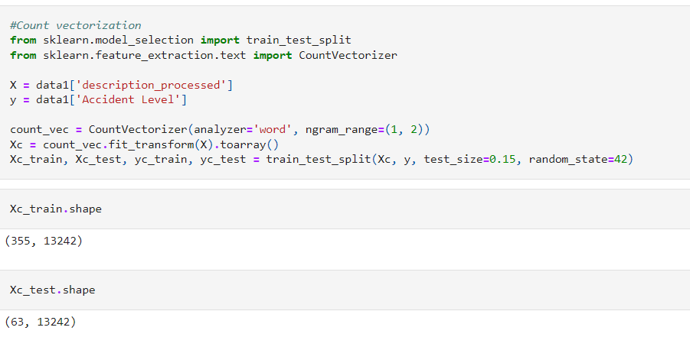

1. Support Vector Classification (SVC)

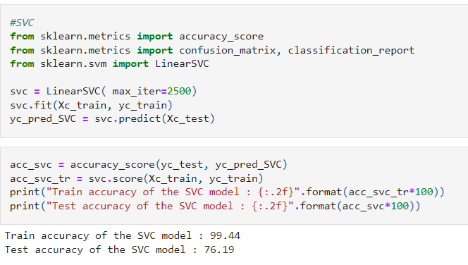

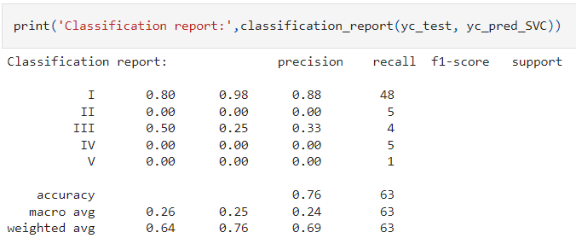

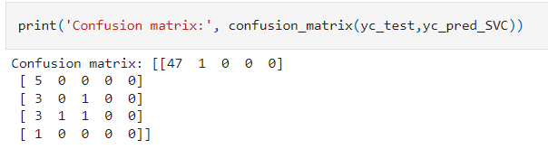

1. Random Forest

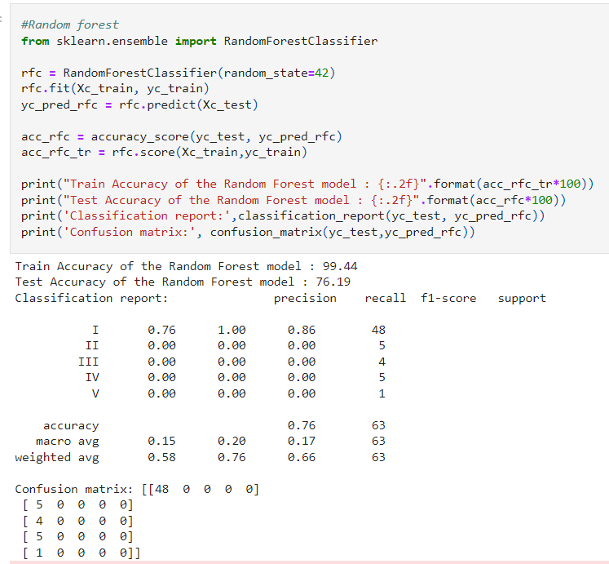

1. Gradient Boosting

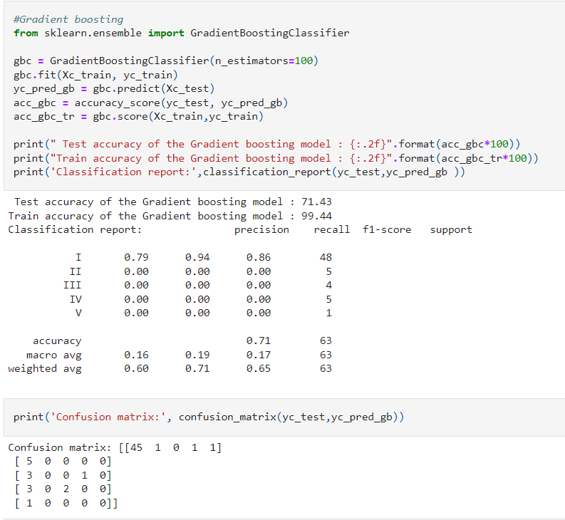

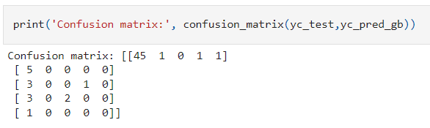

1. XG Boost

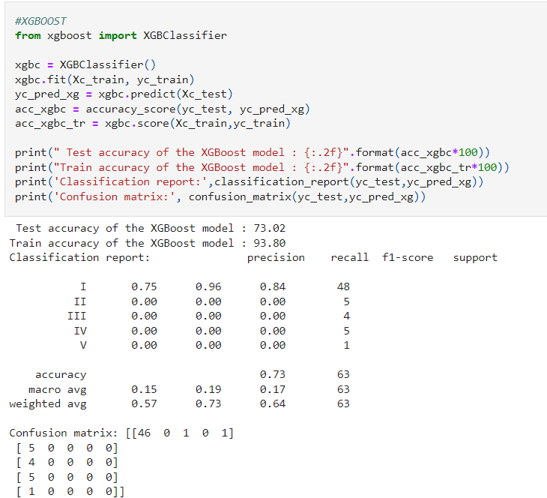

1. K Neighbors

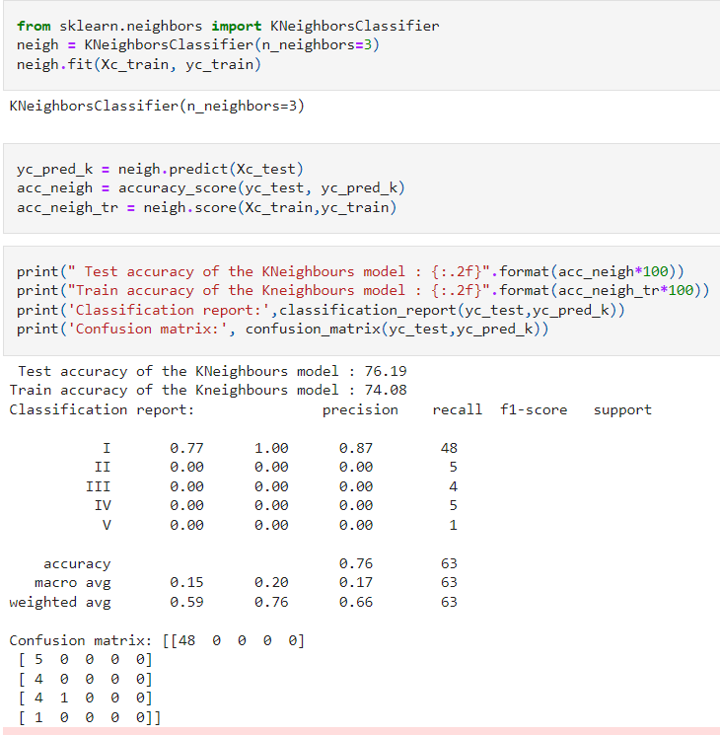

1. Naive Bayes

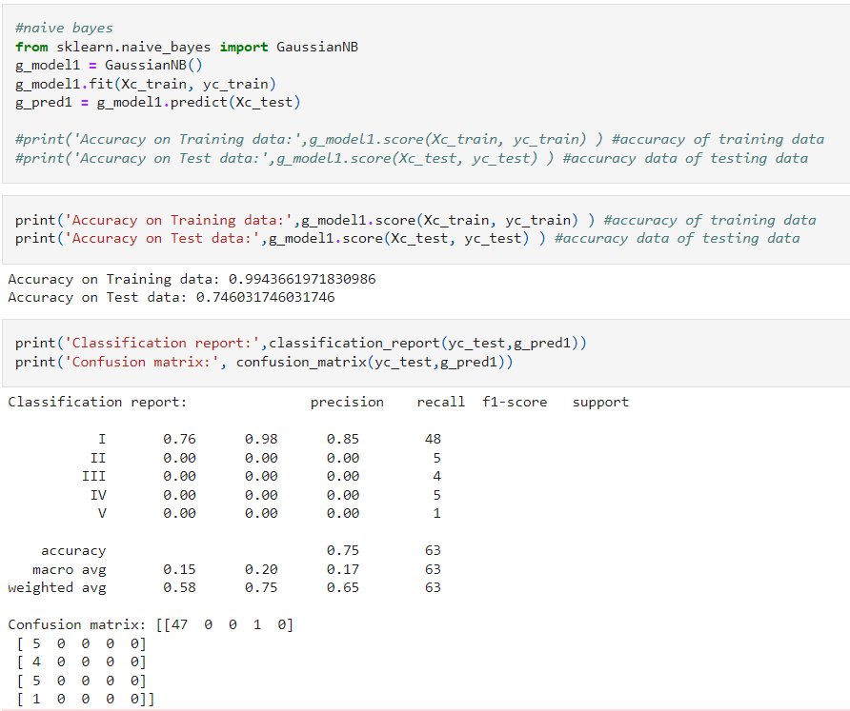

1. Bagging Classifier

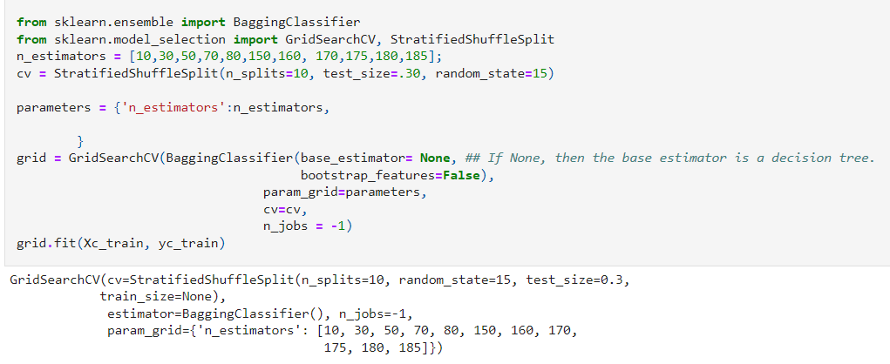

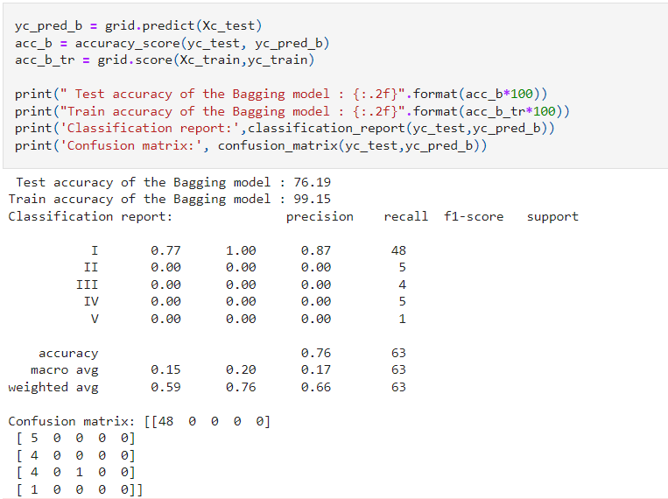

1. Ada Boosting Classifier

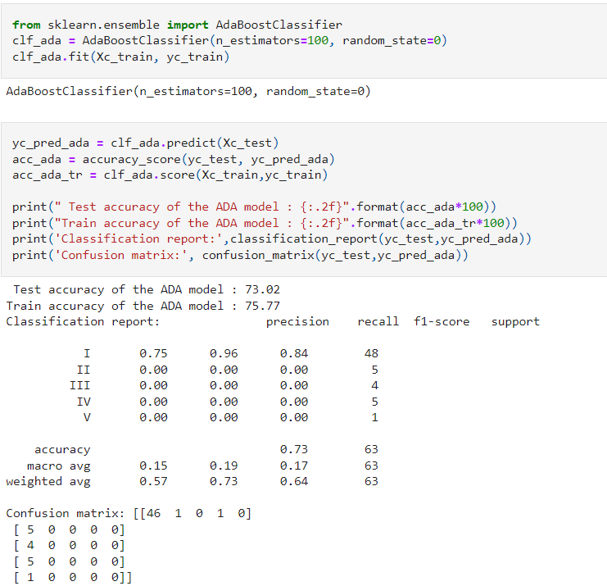

**Potential Accident Level**

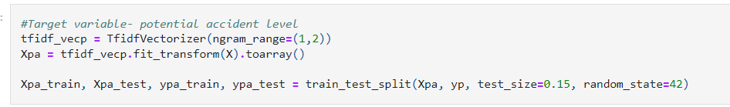

1. Support Vector Machine (SVC)

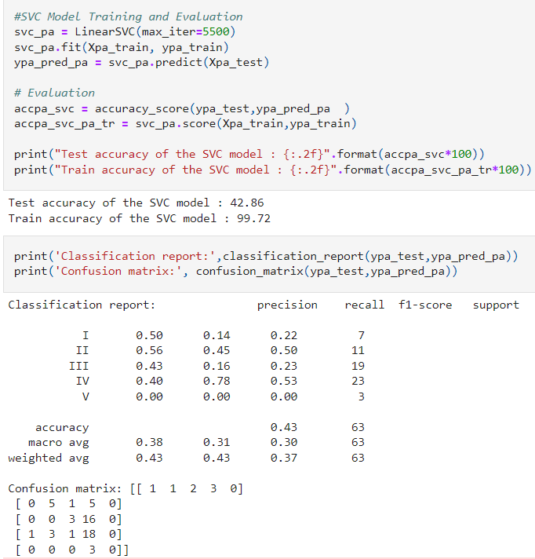

1. Random Forest

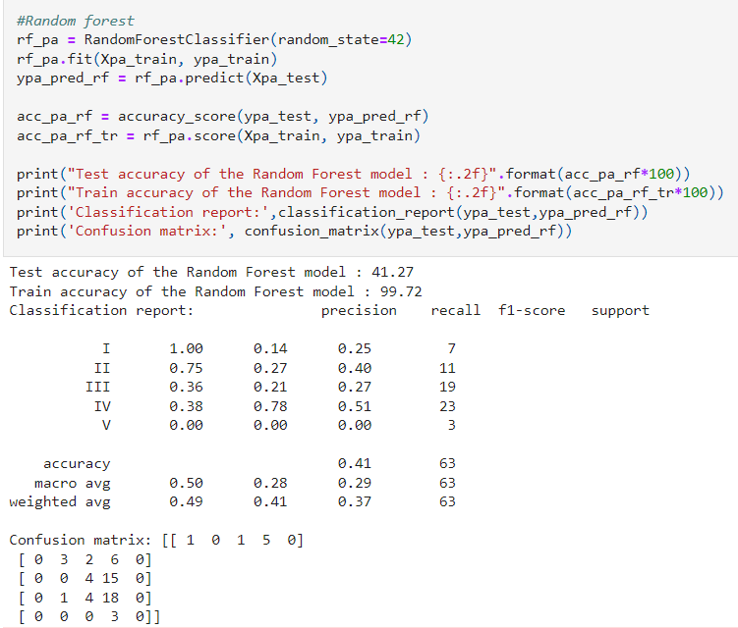

1. Gradient Boosting

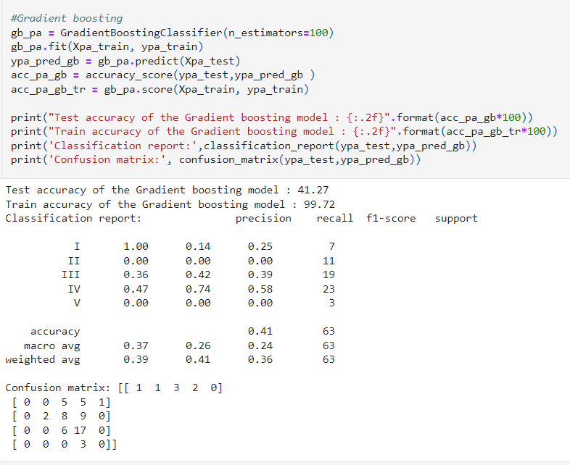

1. XG Boost

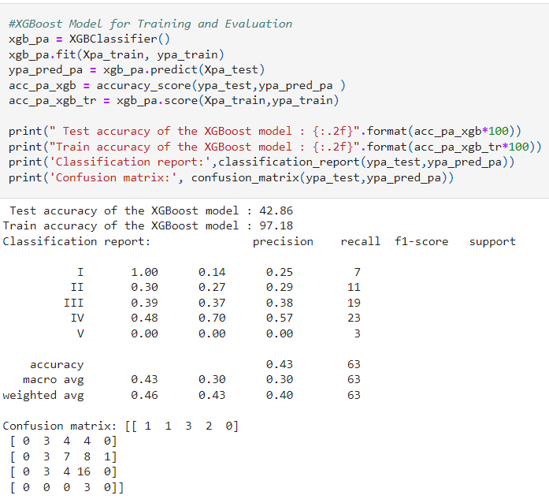

1. K Neighbors

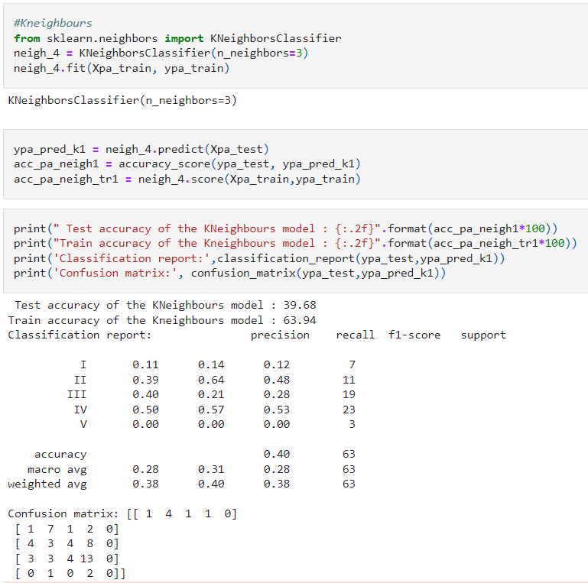

1. Naïve Bayes

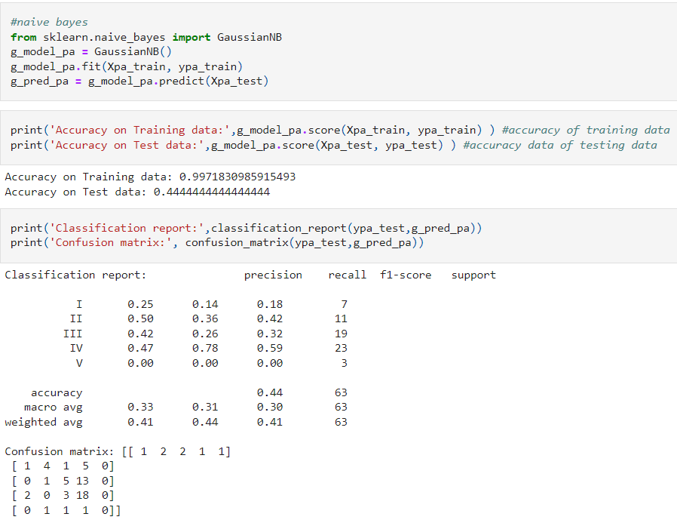

1. Bagging

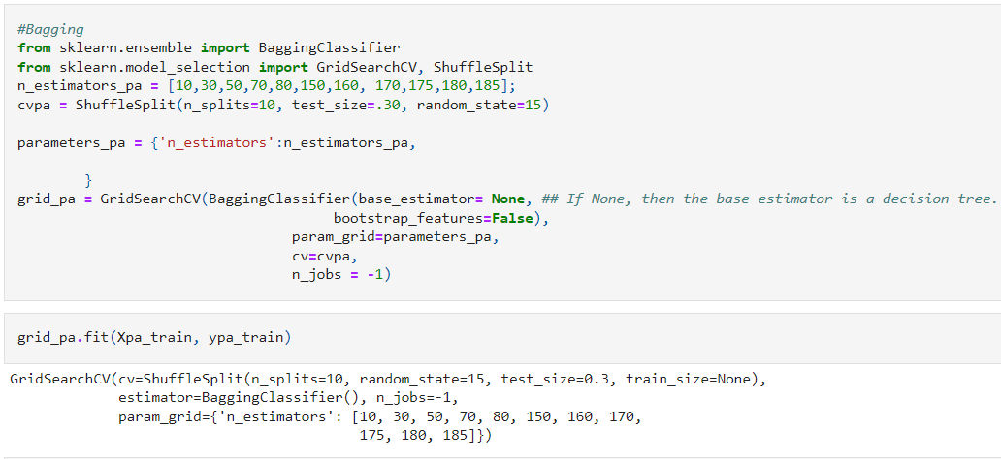

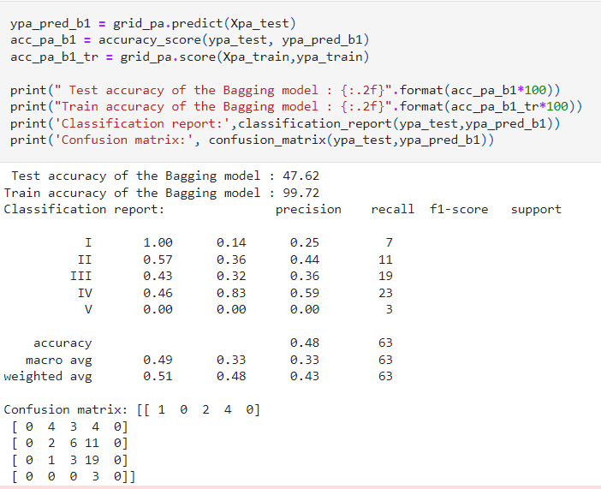

1. Ada Boosting

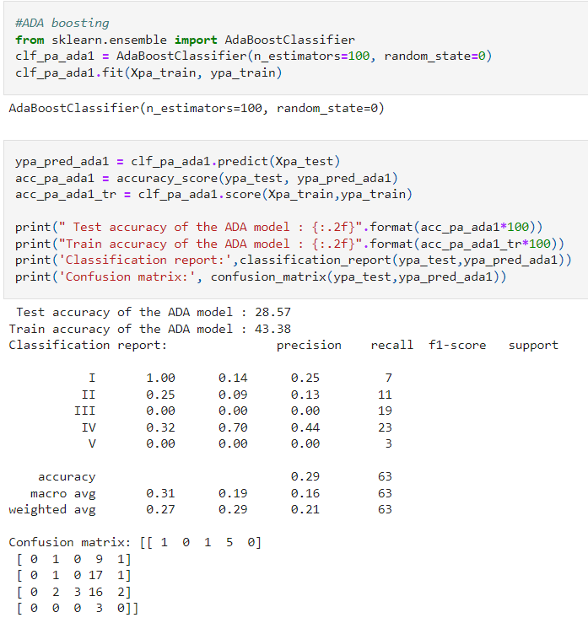

**Comparing all Machine Learning Models**

1. **Accident Level**

* 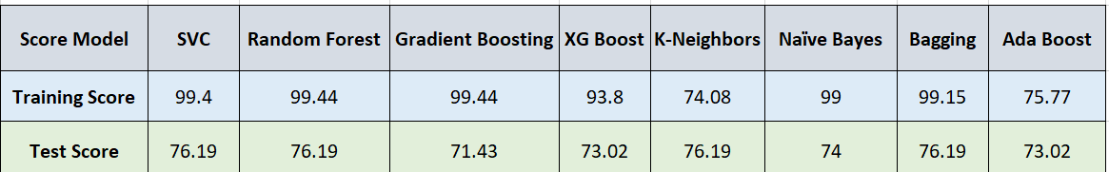**Count Vectorizer**
* **TF-IDF**

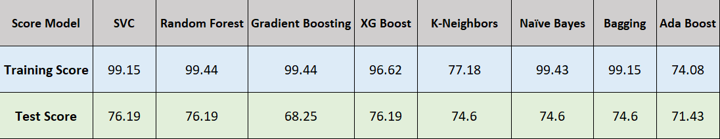

1. **Potential Accident Level**

* **Count Vectorizer**

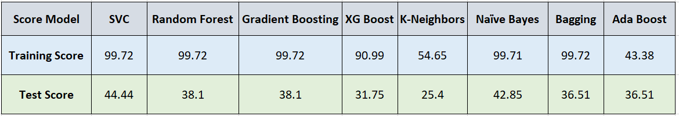

* 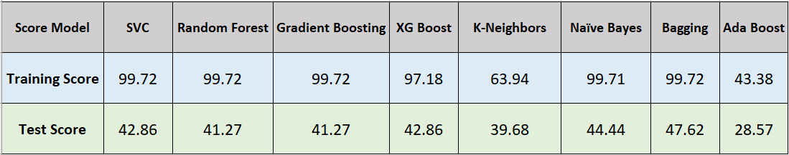**TF-IDF**

Comparing Machine Learning Models with target variable as Accident Level and Count vectorization

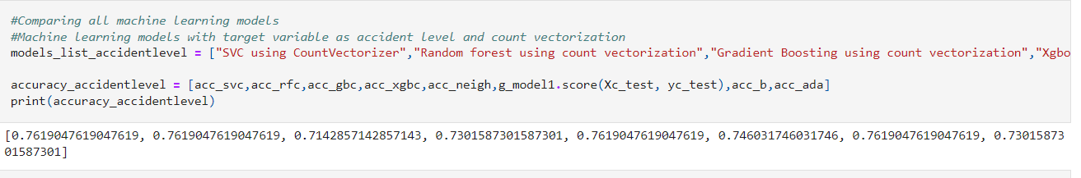

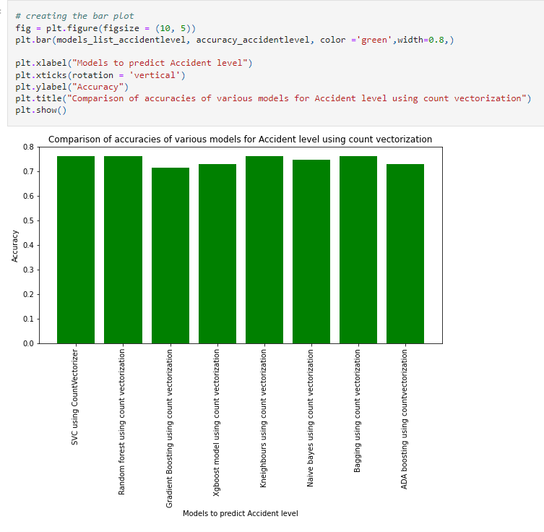

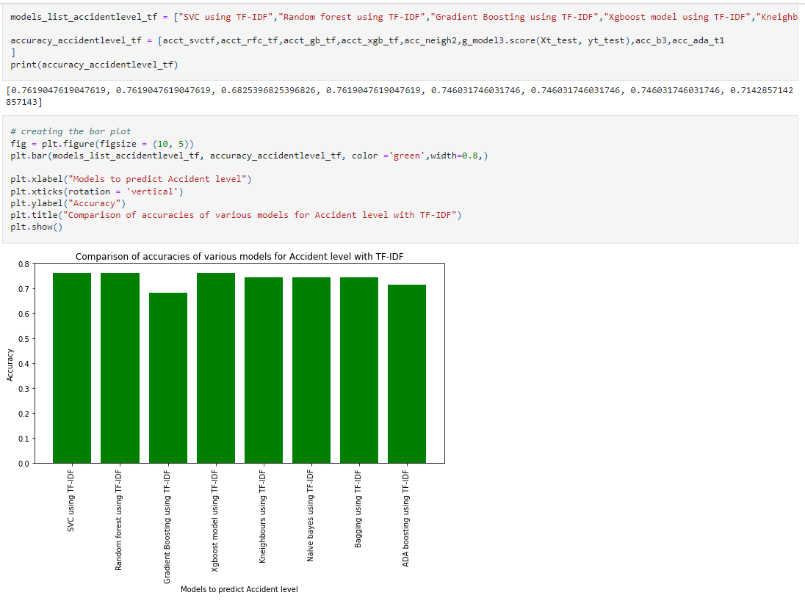

Comparing Machine Learning Models with target variable as Potential Accident Level

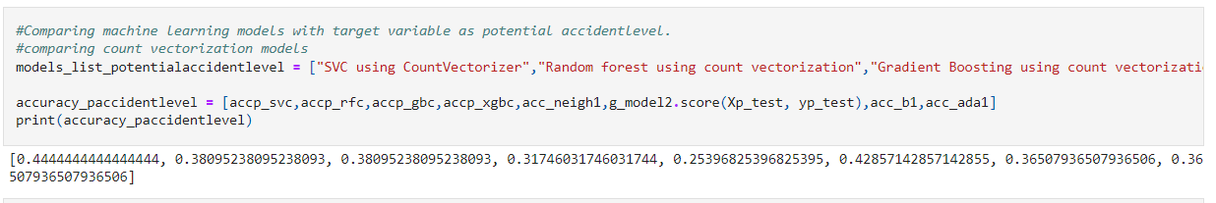

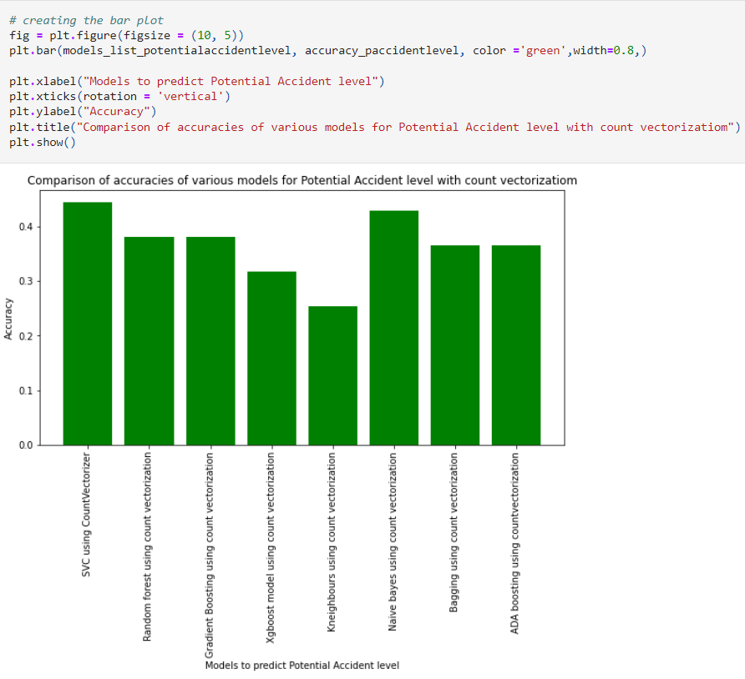

Comparing Machine Learning Models with TF-IDF for the target variable Potential Accident Level

